Table of Contents
Background 2

Timeline 3

Improve Vaccine Access 6
Hosting Clinics 7
Guidance for developing pop-up clinics 7
Pandemic Assistance and Vaccine Equity Grants (PAVE) 7
Misinformation 7
Communicating Health Messages 8
Social Media Toolkit 8
Kansas Immunization Information System WebIz 9
Dashboard 10

References 11

Background

The Immunize Kansas Coalition, Kansas Healthcare Collaborative and the Kansas Department of Health and Environment would like to team up with Kansas colleges and universities to fight flu! While reaching the college/university population with important health messages may be difficult, you are in a unique position to help spread the word about the importance of vaccination.
Flu vaccinated students had less flu-associated school impacts compared to their unvaccinated influenza-infected peers¹:
- ↓ 29% less likely to perform poorly on tests
- ↓ 29% less likely to perform poorly on assignments
- ↓ 25% less likely to perform poorly in class
- ↓ 15% less chance of requiring a healthcare visit even if get infected

This toolkit is designed to help student health and school administrators develop a plan to improve flu vaccination, and if interested participate in the Kansas Collegiate Flu Challenge.

Register for the Kansas Collegiate Flu Challenge:

There are many benefits to engaging in campus vaccination:
- Large numbers of students and staff can be reached in a short period of time
- School facilities can generally accommodate mass vaccination (e.g., gymnasiums, auditoriums, ample parking)
- Reduced student & staff absenteeism
- Friendly statewide competition with school peers
- Most schools, medical clinics and public health partners are familiar with and have conducted vaccine clinics in the past

There are also many challenges and barriers (which we aim to provide potential solutions to in this toolkit):
- Reimbursement of vaccines, purchasing supplies, vaccines and other needs
- Adequate staff to prepare & conduct the clinics
- Immunization activities may need tailored to each school, complicating planning efforts
- Handling and transporting vaccine to many and varied locations requires planning, equipment, and training

Timeline

July-August
When college students get the flu, they experience illness for an average of 5 or more days³

Step 1: Gather the Team. Student health coordinators, medical providers, nurses, health educators, and clinic staff should meet to discuss opportunities and interest in the campaign before the start of the fall schoolyear.

Even if your school does not have the capability to hold on-campus vaccine clinics, partnering with your local health department and medical clinics is a great way to get these vaccines to your students and staff. Your local health department and primary care clinics are familiar with all aspects of vaccine administration (e.g., on-site set up, staffing, vaccine administration). And your local health department has received extra grants from KDHE and is also looking to partner with your campus to expand vaccination activities.

Step 2: Create the Plan. Use this table below to starting drafting the plan, lay out exactly what steps you are going to take to increase vaccination coverage. Not all ideas are feasible, pick a few ideas that work for your school, and execute them well.

Vaccine-Clinic Experienced Campuses | Vaccine-Clinic Inexperienced Campuses
If your campus already has experience in vaccination clinics and flu campaigns, main questions for your student health center and staffing requirements, whether additional clinics will be pursued, and if incentives/swag are offered, what partnerships may facilitate these | If your campus does NOT regularly have vaccine clinics or outreach, consider partnering with your local health department and/or medical clinics which do have this experience. The main questions are going to be partnerships and whether on-site vaccine clinics are feasible, and if not how will your campaign adapt to off-site clinics
- Vaccine clinic dates  - Consider if want to expand clinic days, sites, or hours  - Staffing requirements (if expand clinics)  - Materials –pre-drafted by campaign (adaptable by school)  - Outreach – social media, school newspapers, email  - Engage – pre-med/nursing/pharmacy groups, Greek life, parents  - Incentives – partnerships (e.g., bookstore, pizza, coffee shops, sporting events) | - Partners to offer vaccines (e.g., medical clinics, local health departments, pharmacies)  - Do you want to host on-campus vaccine clinics with partners or hold off-site at their facilities?  - If on-site: where, when (avoid sporting events), staffing & tech requirements (CDC Guidelines For Vaccine Clinic Planning and Checklist)  - Materials –pre-drafted by campaign (adaptable by school)  - Outreach – social media, school newspapers, email  - Engage – pre-med/pharmacy/nursing groups, community-based organizations, parents  - Incentives – partnerships (e.g., bookstore, coffeeshops, pizza/sub shops, sporting events)

Step 3: Assign Tasks. While you have the team together, and after deciding which activities you will engage in, divide the plan into tasks for each person. Set deadlines. The first month, check in weekly or every other week with teammates to ensure accountability.

Assignments | Person Responsible | Due
- Off-site vaccine clinic engagement (local health department, medical clinics, pharmacies)  - Outreach – social media, school newspapers, email  - Engage Campus Groups – pre-med/nursing/pharmacy groups, Greek life, parents  - Seek incentives/gift cards/swag (e.g., bookstore, pizza, coffee shops, sporting events) |  | _______________

August-September
Step 4: Identify vaccination clinics. Especially when there are no vaccination services on campus, put together a list of locations in the community that offer flu vaccination. When possible, list services that provide vaccinations at low or no cost for uninsured and underinsured students. Talk with potential partners about the challenge and provide them with materials. Ensure all flu vaccinations are administered into KS WebIZ (see page **9).
Every Year:
1 in 4 college students gets the flu¹

Colds / flu / sore throat are identified as the 4th leading cause of academic performance impediments in US college students ²
Off-campus immunization services may include:
- Pharmacies
- Local health departments
- Clinics
- Hospitals
- Health fairs
- CDC flu vaccine finder

For campuses with student health clinics and vaccination capabilities, the following strategies may expand immunization coverage rates:
- Standing orders to create vaccine-only visits, this way students do not need an individualized physician order for their vaccination. Standing orders authorize nurses and pharmacists to administer vaccines to all persons meeting certain criteria, including:
  - Protocols to identify patients (immunize.org and CDC protocols)
  - Procedures to provide information on risks and benefits of vaccines
  - Process to record refusals or contraindications
  - Approved vaccine delivery protocol
  - Quality assurance and documentation procedures
- Use every opportunity to vaccinate, including sick and well visits (mild acute illness with or without fever is not a contraindication to vaccinate)

See page **6-7 for ideas to improve vaccine accessibility

September-October-November
Step 5: Implement and monitor. Set a kick-off mass email and set a reminder 2-3 weeks in and regularly there after with updates on status of the school status and vaccination information.
Launch the clinics or pop-up vaccine sites, monitor how things are going as your team makes progress. If something isn’t working, change it. Individualizing your plan to your campus will produce the best results. The way to win the challenge is to get students talking about flu prevention!

Improve Vaccine Accessibility

If you can provide on-campus immunizations, convenient times, and locations for administering immunizations will help increase coverage rates. The following strategies improve vaccine accessibility:

Host clinics: Why make students come to you for their flu vaccine? Set up clinics at major events (e.g., welcome back events, sporting events, libraries, dorms, popular study areas, dining areas) to make it more convenient for students to get their flu vaccine
- Guidance for planning off-site vaccination clinics (CDC)
- Information for businesses and employers (CDC)

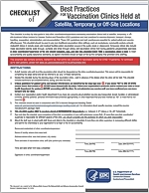  Checklist of Best Practices for Satellite, Temporary or Off-site Locations (CDC) | 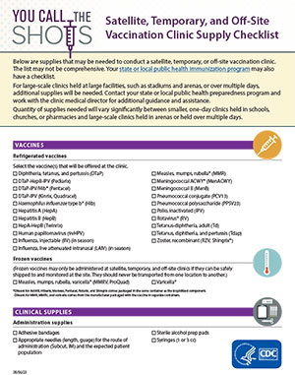  Supply List (CDC) | 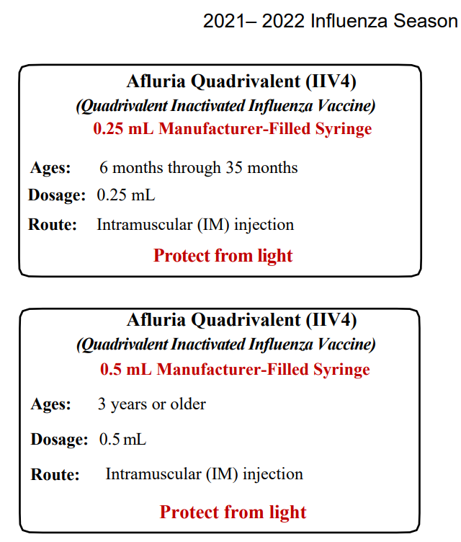  2021-2022 Influenza Season Storage Vaccine Label Examples (CDC)
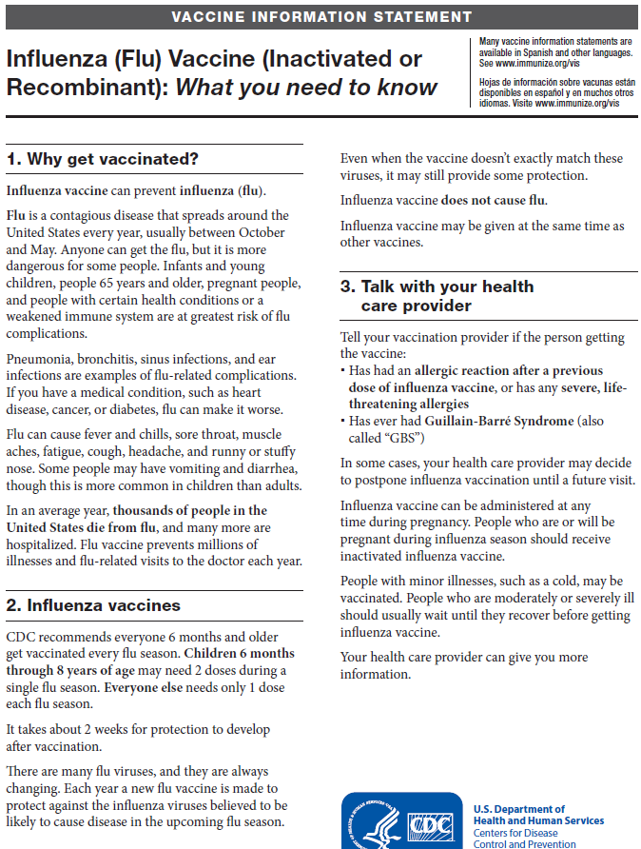  Vaccine Information Statements (CDC) | 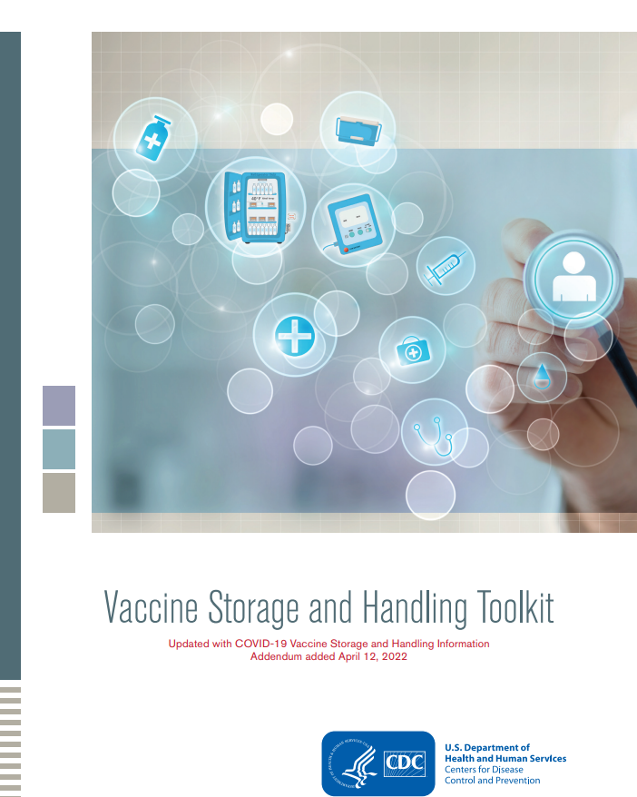  Vaccine Storage and Handling Toolkit (CDC) | 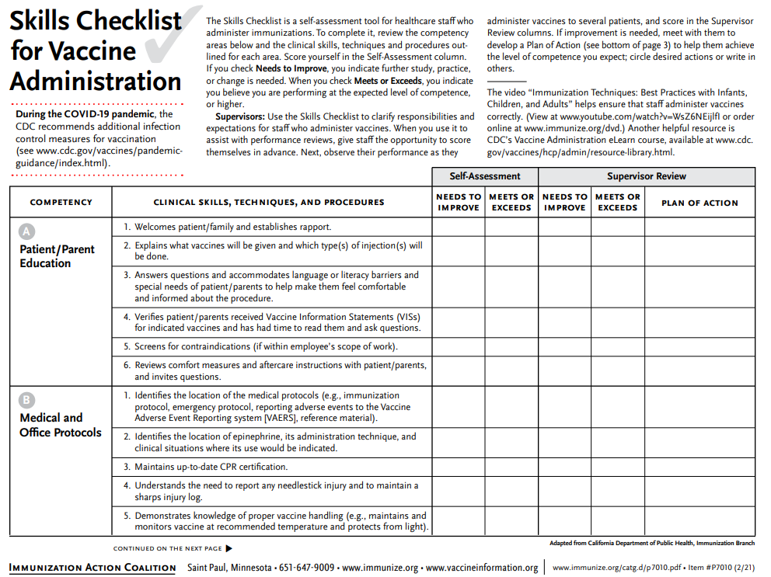  Skills Checklist for Vaccine Administration (Immunize.org)

Easy scheduling: Make time for vaccination! Designate a specific clinic room or area for flu vaccine administration appointments and walk-ins.

Reduce financial barriers: Students do not want to pay out of pocket, so be prepared to help finance the flu vaccine for students. Have a system in place to bill multiple health plans to ensure a variety of healthcare insurance providers are accepted at your facility. You can also provide the option to bill vaccines administered at your facility to student’s university accounts. Additional funds are available in Kansas, and your local health department also likely has funds aiming to vaccinate the community you can tap into.

- Pandemic Assistance and Vaccine Equity Grants (PAVE) is a federal program aiming to improve Kansan’s vaccination, including colleges and universities. Apply June 15, 2022 through December 31, 2022 for up to $10,000. Candidates should aim to spend the majority of vaccination efforts dedicated to COVID-19, and requested funds may be utilized to support and strengthen a variety of immunization planning, including local educational campaigns, media buys (e.g., radio and tv ads), space rentals, transportation costs and personnel. For more information contact PAVE@ks.gov or contact Kansas Governor Laura Kelly’s Grant Office at 785-291-3205.

Provide educational materials on vaccines: The strongest predictor of vaccination is a strong provider recommendation. Ensure both providers and students have sample resources available to learn about flu vaccines and are able to make an informed decision. The flu vaccine can also be given with other needed immunizations (e.g., COVID-19, Tdap, HPV, meningococcal vaccinations) or others depending upon student’s needs.
- Combat Misinformation: A 2022 survey of Kansas health department administrators found 45% do not feel comfortable or equipped to combat vaccine misinformation in their communities. For more information, visit Building Vaccine Confidence in Kansas prepared by the Kansas Association of Local Health Departments (KALHD). KDHE and KALHD host training opportunities, and have partnered with IKC to develop a step-by-step guide for social media using messages from IKC’s Get Caught Up Campaign.

Vaccinate on Campus, Schedule around classes: If possible, schedule around student class times and schedules, and offer a variety of clinic times, including nights and weekends. Clinics scheduled between 9:00 am and 5:00 pm may not be ideal timing for students. Focus groups with Kansas undergrad students report they were most likely to get vaccinated when passing through the student union, common outdoor/plaza areas, gyms, or recreation centers. Offering a pop-up clinic at outside sporting events or offering free tickets, or free food coupons would be especially persuasive in getting them vaccinated. Kansas students reported they were less inclined to get vaccinated if they had to go off campus, although some smaller schools did report the local pharmacy within the grocery store was a preferred site.

Communicating Health Messages

IKC has drafted vaccination messaging directed to Kansas schools to be posted on social media, sent via email blasts, and we will also provide pre-drafted articles describing the competition to go into your school newspaper.
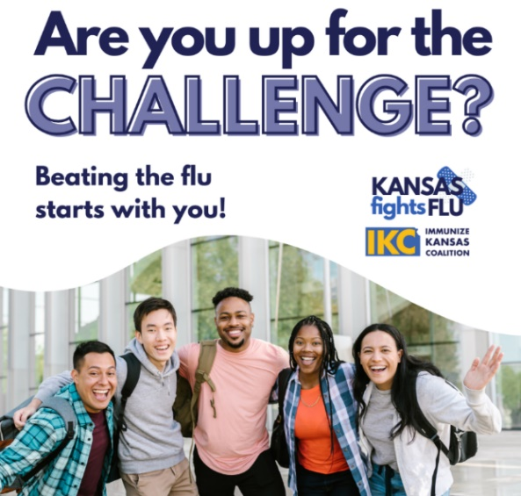
Social Media Toolkit: IKC’s Social Media Messaging Toolkit includes captions that go along with assigned graphics. In the toolkit, you will also find a link to the collegiate challenge Canva template. By accessing this template, you will have the ability to edit the images with your school colors and include a logo. If you do not have access to Canva Pro, some images may not appear correctly. In this case, you will need to contact Paige Lewis at IKC (paige.lewis.ks@gmail.com) for additional updates.

Email Blasts: Partner with your university public relations team to send email blasts to students. Bonus: this is a great exercise to practice emergency communications messaging capabilities also. Use this opportunity to share information about the Flu Challenge, why students should get vaccinated, and where they can get vaccinated.

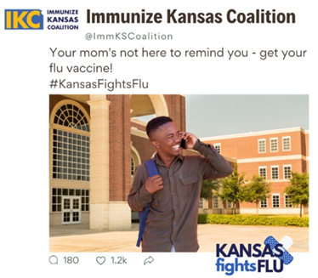
Influencers: Kansas undergraduate students report they’ve been involved or have been more persuaded to participate in competitions when their peers serve as champions and/or are involved in competitions. Schools can reach out to students of good report, those in pre-med, pre-nursing, pre-pharmacy clubs, RAs, TAs, interns and/or engage the student leaders in Greek to serve as vaccine “champions”. An incentive is generally offered for those willing to be a peer influencer, such as gift cards, bookstore credits, or scholarships. Engage marketing students who can practice their skills hands on.

Personal stories: Presenting personal stories can help emphasize the importance of annual flu vaccination. Bringing attention to some of the stories may help students relate and be more inclined get vaccinated. Pointing out also that becoming sick with flu affects academic performance is also a motivating. Voices for Vaccinations offers concerns, aspirations and questions diverse communities have regarding COVID-19 vaccinations and distribution in Kansas. This group also aims to develop culturally appropriate messaging for more informed dialogue across the state.

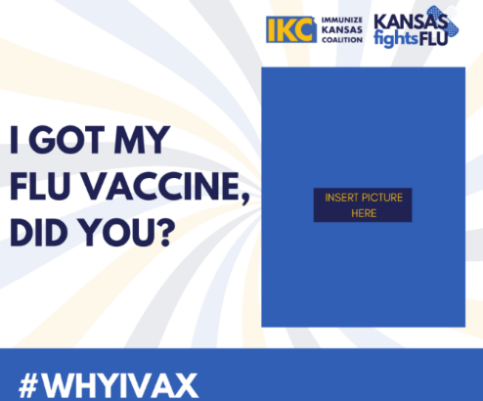
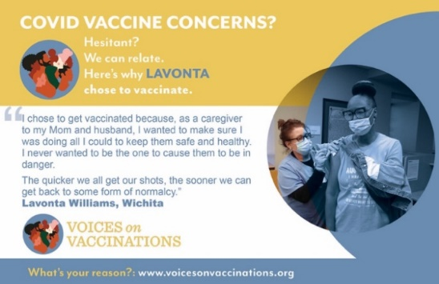
Internal Competitions: Another way to get students involved is for internal competitions.
- Majors/schools
- Residence halls
- Campus organizations
- Greek life
- Athletic teams

Kansas Immunization Information System – WebIZ

Kansas WebIZ is a great tool to assist in increasing, and tracking, immunization rates. WebIZ is the official statewide, web-based registry designed to capture all immunizations administered in Kansas for all age groups. It provides a centralized location for all immunization records and provides significant advantages for health management by:
- Providing patients, healthcare providers, schools, and childcare facilities timely access to complete, accurate and relevant immunization records
- Assists healthcare providers and pharmacies access immunization coverage and identify areas of need

If you are currently registered as a WebIZ user, continue to log all immunizations in WebIz, including those administered during the challenge.
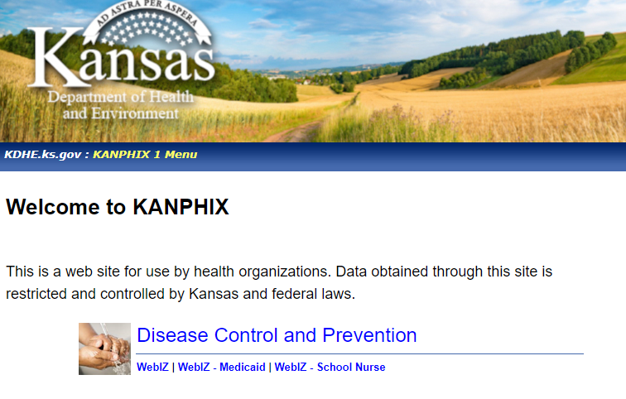
If you are not yet registered, visit KANPHIX to start the process:
- Go to KSWebIZ website: https://kanphix.kdhe.state.ks.us/

- Under the blue Disease Control and Prevention heading, select the corresponding link marked ‘WebIz’, ‘WebIz-Medicaid’, or ‘WebIz-School Nurse’
- Enter your Username and Password
- Select ‘Login’
- Next screen requires change of password, enter your username, existing temporary password, a new password, and confirm the new password
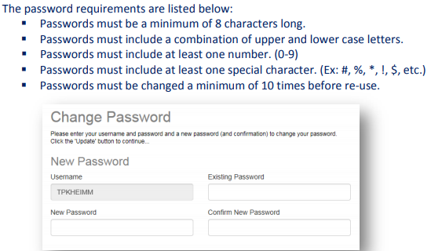

- Fill in the answer to 5 of the listed questions, these will assist with getting logged in if you forget your password in the future
- Contact KDHE Immunization Helpdesk if you need assistance (immregistry@kdheks.gov)
- You are then taken into your KSWebIz account
- Select ‘Update’

Dashboard

IKC will host the challenge dashboards on their #KansasFightsFlu webpage. Data will be pulled in from KS WebIz for on-site locations, and for those without student health clinics that are providing vaccinations QR codes will be utilized to track vaccination rates (QR codes specific to each school will be utilized for all campuses to be eligible for grand prizes). The Dashboard will be updated once a week and we encourage links to individual school social media accounts and student health clinic pages. Rates are calculated on total students vaccinated as the numerator, with the denominator being the total student body (as of the financial aid census date).

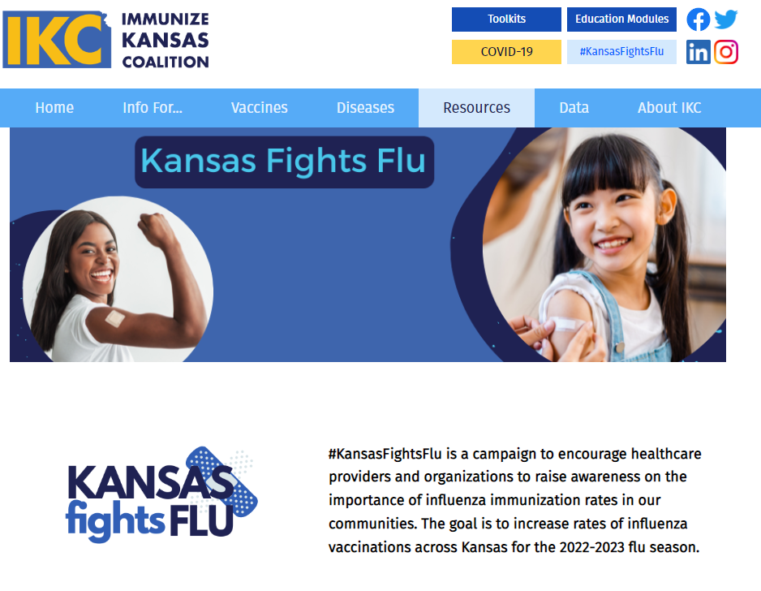

References
- Nichol K., D’Heilly S., Ehlinger E. Influenza vaccination among college and university students: impact on influenzalike illness, healthcare use, and impaired school performance. Archives Pediatric Adolescent Medicine. 2008;162(12): 1113-1118.
- Reference group data fall 2021 report. American College Health Association National College Health Assessment Website. Published 2022, accessed June 17, 2022. https://www.acha.org/documents/ncha/NCHA-III_FALL_2021_REFERENCE_GROUP_EXECUTIVE_SUMMARY.pdf
- Nichol K., Tummers K., Hoyer-Leitzel A., et al. Modeling seasonal influenza outbreak in a closed college campus: impact of pre-season vaccination, in-season vaccination and holidays/breaks. PLo

